Paper Review of Cheng by 06/12/2020

* Title: OpenMVG: Open Multiple View Geometry
* Needs
  + Traditional 3D reconstruction tools (such as Matlab or OpenCV) require a huge workload and the complexity of calculation.
  + Traditional tools are not able to complete all the algorithms in each 3D reconstruction steps, especially be short of Structure from Motion.
* Objectives
  + Implement an entire pipeline from SfM to 3D reconstruction, including image processing, feature detection, multi-view geometry solvers. Each step could run respectively too, to complete certain features.
  + Accurate calculation of multi-view solid geometric models.
  + In order to have more compatibility and expansibility, and to have efficient performance, the codes had better be written in C++, constructed in CMake System.
* Methodology
  + Provide several common methods for image processing and feature detection
  + OpenMVG provides a neighbor search function that integrated several efficient and accurate algorithms, to compute the nearest 3D point and make images correspond to each other.
  + Some SVG data are kept and updated to maintain details while zooming in and zooming out images during the whole process.
  + For different relative positions of each image, OpenMVG provide different solver suiting each situation, and to match feature points more accurately.
* Results (little concrete results demonstrated)
* OpenMVG has been the most popular framework of 3D reconstruction tool in Github, which has most contributors, most watchers, stars and fork.

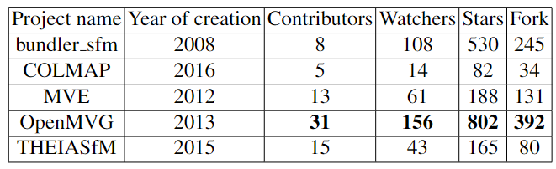

* OpenMVG is enough professional that many large laboratories are using it to make research.
* Conclusion
  + OpenMVG is a general framework to make multiple view models, especially make 3D reconstruction. When results from OpenMVG are output, and then a complete three-dimensional reconstruction can be achieved through dense matching, surface reconstruction, and texture mapping.
  + openMVG has a complete SfM process, which reconstructs the sparse object points of the entire scene from a set of image sequences, and at the same time obtains the internal and external parameters of the shooting camera, which can be used for photogrammetry or camera orientation process